INDIRA COLLEGE OF COMMERCE AND SCIENCE, PUNE



FY M.Sc. Semester II Project

2023-2024

**A Project Report**

**on**

**“Event Management System”**

**SUBMITTED BY**

**Shubham Pingale (44) and Irfan Kalekar (09)**

**UNDER THE GUIDANCE OF**

**PROF. AWANTIKA BIJWE**

**Project Certificate**

**(should be taken from project guide)**

**TABLE OF CONTENTS**

**CHAPTER 1: INTRODUCTION**

1.1 Existing System and Need for System

1.2 Scope of Work

1.3 Operating Environment – Hardware and Software

**CHAPTER 2: PROPOSED SYSTEM**

2.1 Proposed System

2.2 Objectives of System

**CHAPTER 3: ANALYSIS & DESIGN**

3.1 Data Flow Diagram (DFD)

3.2 UML Diagrams

3.2.1 Class Diagram

3.2.2 Use Case Diagram

3.2.3 Activity Diagram

3.2.4 Sequence Diagram

3.3 Entity Relationship Diagram (ERD)

**CHAPTER 4: USER MANUAL**

4.1 Menu Screens

**CHAPTER 5: Limitations and Enhancement**

5.1 Drawbacks and Limitations

5.2 Proposed Enhancements

5.3 Conclusions

5.4 Bibliography

**1) INTRODUCTION**

This is an online event management system software project that serves the functionality of an event manager. The system allows only registered users to login and new users are allowed to resister on the application. This is proposed to be a web application. The project provides most of the basic functionality required for an event. It allows the user to select from a list of event types. Once the user enters an event type eg(Marriage, Dance Show etc), the system then allows the user to select the date and time of event, place and the event equipment’s. All this data is logged in the database and the user is given a receipt number for his booking. This data is then sent to the administrator (website owner) and they may interact with the client as per his requirements and his contact data stored in the database.

* 1. **Existing System and Need for System**

Existing System This existing system is not providing secure registration and profile management of all the users properly. This system is not providing on-line help. This system doesn’t provide tracking of user’s activities and their progress. This manual system gives us very less security for saving data and some data may be lost due to mismanagement. This system is not providing event management through internet. This system is not providing proper events information. The system is giving manual information through the event management executer.

* 1. Scope of Work

The scope of the project is to build an Event Management System without any issues that is designed to facilitate managing events without any trouble. Benefits: It has various benefits: - Manage College-level events with ease. - Secured registration system - Auto generate user reports - Provide abstraction of implementation details.

Goals: The goal of this project is to deploy proposed project, that is Event Management System successfully.

Objective:

The main objective of this project is to develop general purpose software for Event Management mainly to computerize the managing process. The proposed software will reduce the paper work as well as manual labor of the Company.

Key Features:

* User Registration/Login.
* Admin Login
* Event Selection (User may select type of event)
* Event place selection (A list of places available and associated rent is given on website to select from)
* Event equipment selection (A list of equipment including stages, mikes, speakers lighting, seats is displayed on website to select from)
* Food Package Selection.
* Cost calculation (The final cost is calculated by adding event place, equipment and expertise cost)
* Receipt mailing (Receipt is mailed to the user)
  1. Operating Environment – Hardware and Software

Hardware requirements:

* Processor- Intel core i3 and above.
* RAM- 4GB

Software requirements:

* Operating System- Windows 10 and above
* Dot Net Framework- Visual Studio, ASP
* Database- MySQL

**2) PROPOSED SYSTEM**

**2.1) Proposed System**

The proposed Event Management System is developed to assist students and faculties manage events with ease. It is further divided into modules such as:

- Event tracking: The events created are stored in a MySQL Database in Jaws DB server that is hosted by AWS. The event data is retrieved through SQL queries. This allows users to check all the listed Events in the web page. New events can be added with ease by storing event details such as Event Name, Event type, Event registration fee, and Event poster in the Database. These details are retrieved by the web application through SQL queries. - Registration of Users: Users can register to the event of their choice with the help of the Event Management System. The Web application contains a form which asks for user information such as Name, Email, Mobile, Event to register, Class, Section and Address. This information will help to analyze and prepare reports about the events and the users registered in the events.

Documentation: The Web application contains clear cut documentation of various events and the information about each of the events. This documentation will be useful for the users to get to know about the information that they are interested. The users can register to the events of their choice after going through the documentation provided in the web application.

Automated delivery of Reports Detailed reports can be dynamically generated by the web application and can be mailed to the admin. These reports include the details of the users registered. This will help in eliminating manual work in going through each registration to get analytics of the user registrations. –

Accessible/ Dynamic Web Application. The Event Management System is a web application that can be accessed through any device such as a desktop computer, a mobile phone, a tablet, or event smart watch. The web application requires a browser that can load web pages. Hence, the web application is accessible and dynamic.

Module Description:

Event Management System is divided into following modules:

1. Landing module

2. Documentation module

3. Events module

4. Registration module

5. Admin module

1. Landing module: This module is the entry point of the Event Management System. It is the home page of the web application. It contains basic information of the Event being conducted. For example, if a Tech fest is being conducted in a college, The landing module can list information of the tech fest. Details such as name, posters, possible dates of the event can be displayed in the Landing module.
2. Documentation module: Documentation module is developed to assist the users in registering to the events. It will contain information on how to register to particular event and will guide the users across the web application. Documentation module is solely to assist users in using the Event Management System.
3. Events module: Events module contains in detailed information of various events that are added to the Database. Various categories or types of events such as the Technical, Non-Technical events, Cultural events, etc. can be listed in the documentation module. And the organized events can be listed under the type of events as per their category. This module will contain names of the events, registration links, price of registration (if applicable), posters of the events, and more information about each of the events.
4. Registration module- The registration module is aimed to help the users register to the events of MN their choice. It is achieved by the help of a Registration form that asks users the information such as their Name, Email, Mobile, Event to register, Class, Section and Address. The user will submit the form after filling their details using the submit button. The submit button will trigger the back-end code and will store the user information in the user database. In this way, a user can successfully register in the events if their choice.
5. Admin module- The admin module is implemented by making use of the concept of abstraction. The admin module will not be visible to the end users. It can only be accessed by the admin and will contain information about the user analytics. The admin will be able to add new events and modify or delete the existing events. These changes will be reflected in the events module that is accessed by the end users. The admin module is important to make overall changes to the events directly from the web application and is used by the students or faculties who are in charge of organizing the events.

Future Scope of the Project:

* Reduction of paper work
* User friendly
* Reduction of human efforts and manual labor
* Additional features can be added to it based on requirements
* Reduces time considerably

**2.2) Objectives of System**

The main objective of this project is to develop general purpose software for Event Management mainly to computerize the managing process. The proposed software will reduce the paper work as well as manual labor of the Company.

## Reduce time, cost and resource

## Report generation and distribution

## Improve operational interfaces

## Flexible and adaptable system

3) ANALYSIS & DESIGN

**3.1) Data Flow Diagram (DFD)**

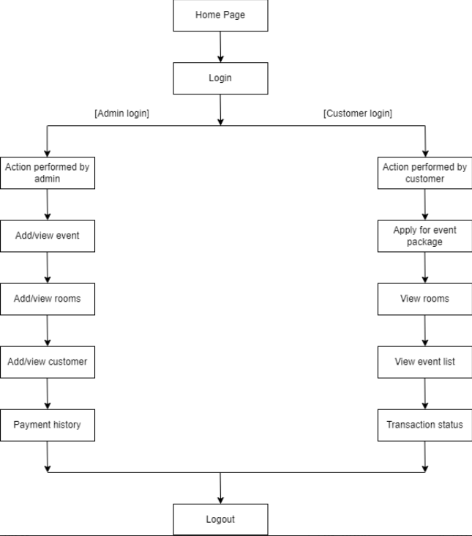

**3.2) UML Diagrams**

**3.2.1) Class Diagram**

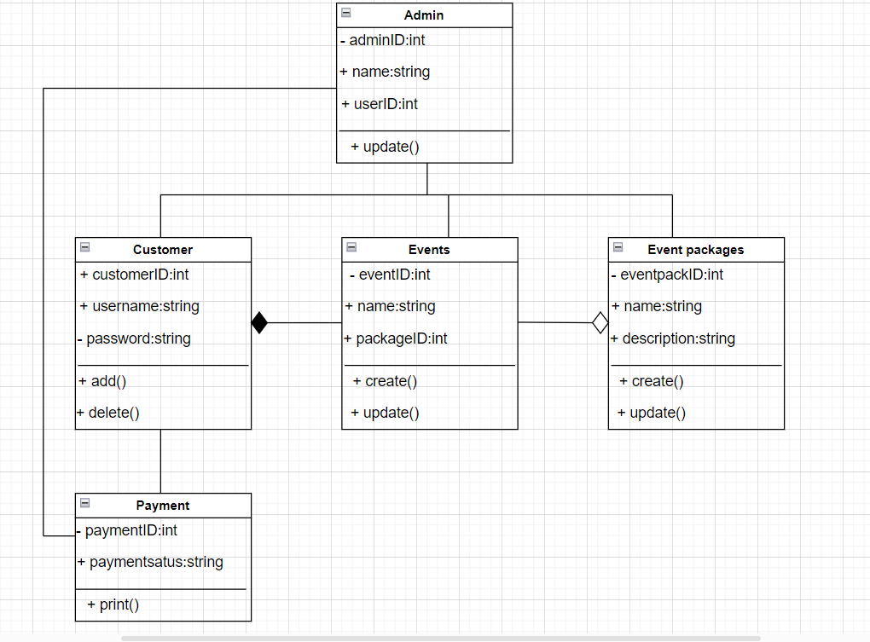

**3.2.2) Use Case Diagram**

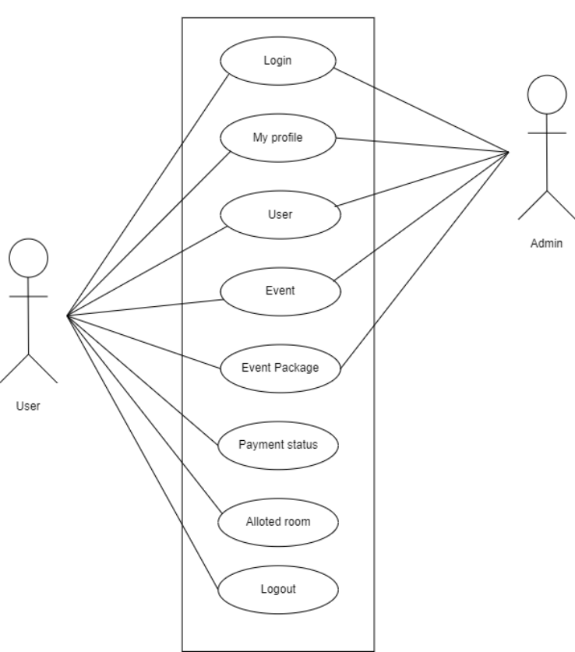

**3.2.3) Activity Diagram**

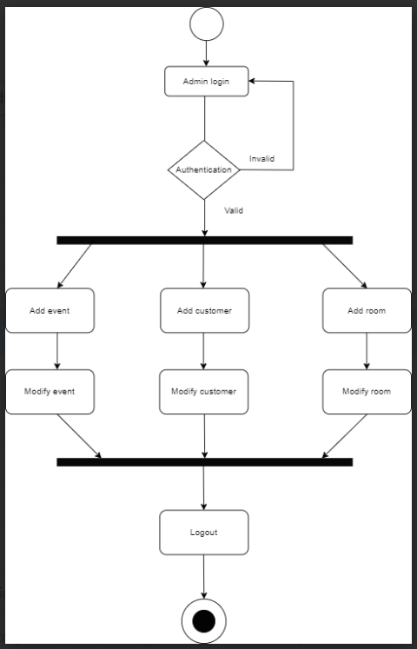

**3.2.4) Sequence Diagram**

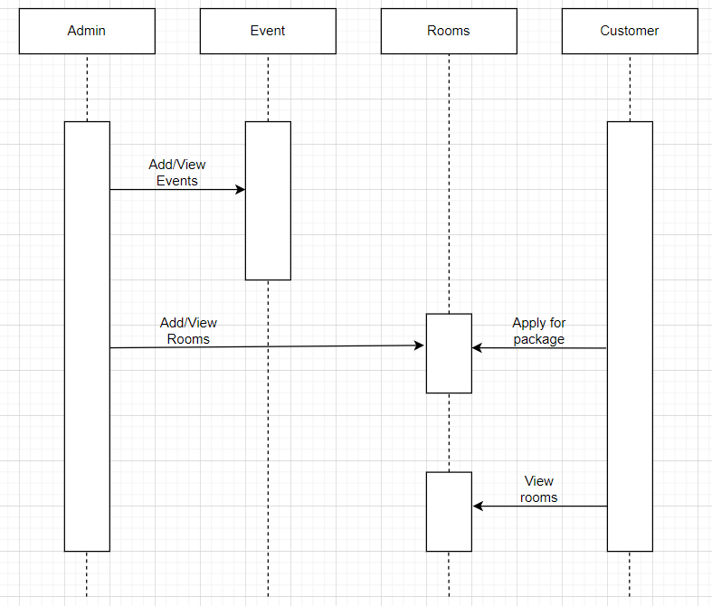

**3.3) Entity relationship diagram**

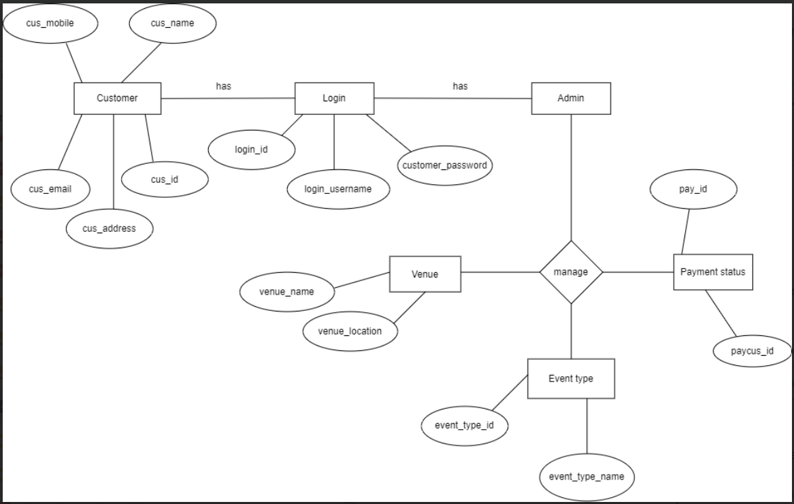

**4.1 Menu Screens**

**Homepage**















**Login Page**

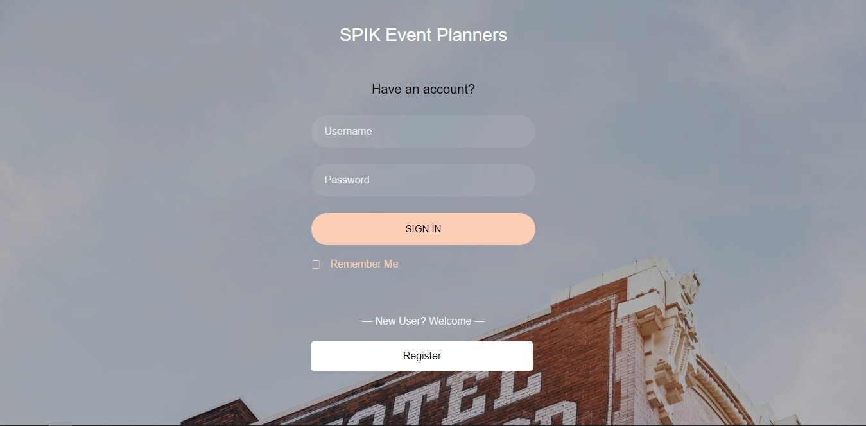

**Dashboard**

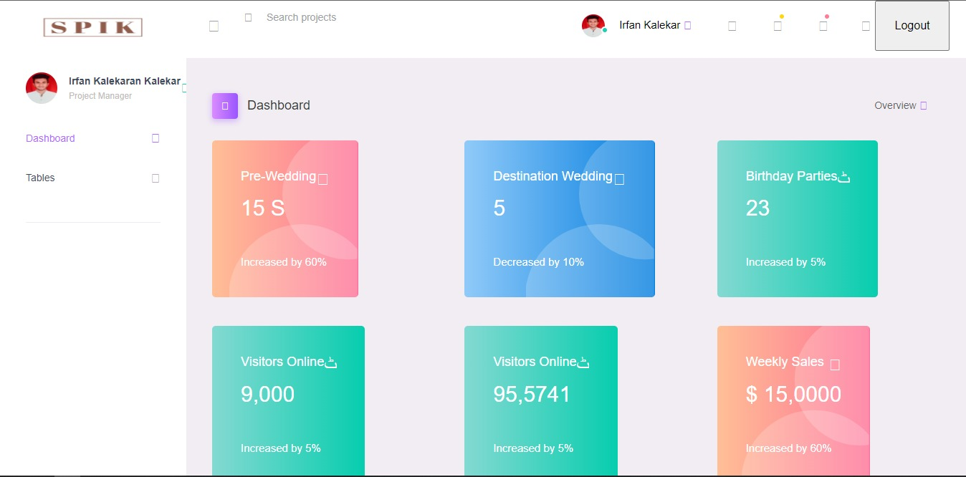

**Registration Page**

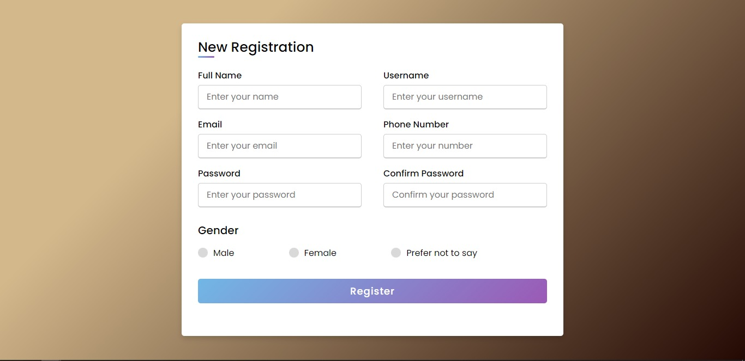

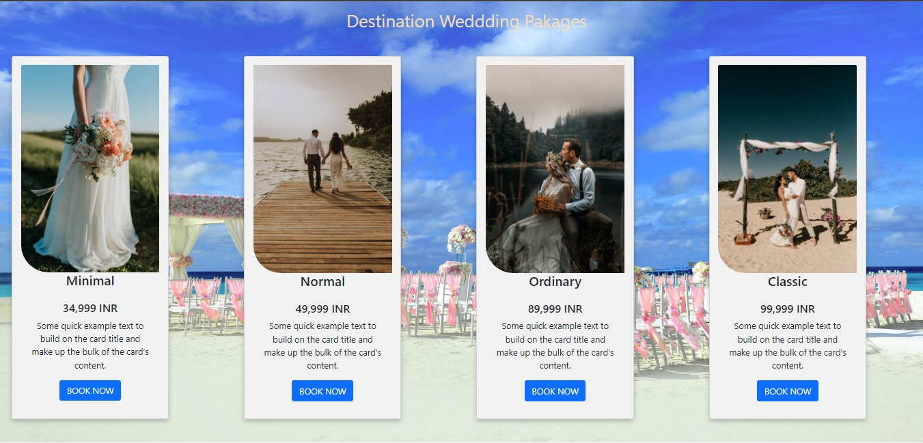



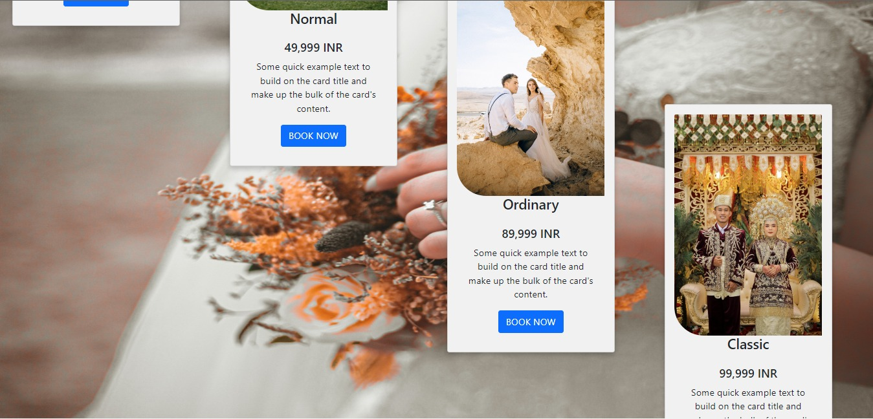

**5: Limitations and Enhancement**

* 1. Drawbacks and Limitations

Event management systems offer numerous benefits and conveniences for organizing and managing events. However, they also have certain drawbacks and limitations that are worth considering. Here are some common drawbacks associated with online event management systems:

Dependency on Internet Connectivity: Online event management systems rely on a stable internet connection. In areas with limited or unreliable internet access, the system's usability may be compromised. This can make it difficult for organizers and attendees to access event information or participate fully.

Security Concerns: Event management systems involve the collection and storage of sensitive data, such as attendee information and payment details. If the system lacks robust security measures, it could be vulnerable to data breaches or unauthorized access. Organizers need to ensure the system they choose has proper security protocols in place.

Customization Limitations: Online event management systems provide a predefined set of features and functionalities, which may not align perfectly with the unique requirements of every event. Customization options may be limited, making it challenging to tailor the system to specific event needs.

User Support: While many event management systems offer customer support, the quality and availability of assistance can vary. In some cases, getting timely and effective support may be a challenge, leading to frustration and delays in problem resolution.

Lack of Face-to-Face Interaction: Online event management systems are convenient for remote collaboration, but they lack the personal touch and face-to-face interaction that physical events provide. Building relationships and networking can be more challenging in an online environment.

It's important to consider these drawbacks and limitations when choosing an online event management system and develop strategies to mitigate potential challenges to ensure a successful event.

* 1. **Proposed Enhancements**

Proposed enhancements for an event management system can be tailored to specific needs and requirements. Here are some general enhancements that can improve the functionality and effectiveness of an event management system:

Improved User Interface: Enhance the user interface (UI) to make it more intuitive, visually appealing, and user-friendly. Simplify navigation, streamline workflows, and ensure a seamless experience for both organizers and attendees.

Streamlined Registration Process: Optimize the registration process to make it quick, easy, and user-friendly. Implement features like pre-filled forms, guest registration options, and social media login to reduce barriers and increase registration conversion rates.

Dynamic Agenda and Session Management: Provide a dynamic agenda management system that allows organizers to easily create, update, and manage event schedules. Enable attendees to customize their agendas, set reminders, and receive notifications for session changes or updates.

Networking and Attendee Engagement: Include features that facilitate networking and attendee engagement. This can include virtual chat rooms, matchmaking algorithms, attendee profiles, and networking opportunities before, during, and after the event.

Integrated Communication Tools: Enhance communication capabilities within the system. Include features such as event-wide announcements, session-specific notifications, and direct messaging between attendees, speakers, and organizers.

Seamless Integration with Third-Party Tools: Integrate the event management system with popular third-party tools and platforms. This can include email marketing software, CRM systems, survey tools, virtual event platforms, and social media platforms for seamless data transfer and enhanced functionality.

Real-time Analytics and Reporting: Implement robust analytics and reporting capabilities to provide real-time insights into event performance. Enable organizers to track registration metrics, attendee engagement, session popularity, and other key performance indicators.

**5.3 Conclusion**

In conclusion, an event management system project offers numerous advantages for organizing and managing events efficiently. It streamlines processes, improves communication, and enhances the overall event experience for organizers and attendees. However, it is essential to consider the drawbacks and limitations associated with such systems.

Despite these limitations, online event management systems can be highly beneficial when chosen and implemented appropriately. Organizers should carefully assess their event requirements, choose a reliable and secure system, provide adequate training to users, and plan for contingencies to mitigate potential challenges.

By considering both the advantages and limitations, organizers can make informed decisions and leverage the capabilities of event management systems to create successful and memorable events. With proper planning, implementation, and ongoing support, an event management system project can significantly streamline event operations and deliver a positive experience for all stakeholders involved.

**5.4 Bibliography**

* [www.mobirise.com](http://www.mobirise.com)
* [www.youtube.com](http://www.youtube.com)
* [www.bootstrap.com](http://www.bootstrap.com)